**Assignment 2 Question 2: Analytics Insights**

**Overview**

The Airbnb listings market is highly competitive, given the abundance of attractive options available to guests, especially in Vancouver where the city offers many highly-rated listings. That being said, Airbnb hosts must ensure they provide the **expected standard of quality**, while maintaining **competitive pricing**. The following three tableau worksheets packaged into a final dashboard offers a valuable tool for Airbnb hosts to gain relevant insights into customer demand and expectations, how to better price their properties and revaluate current operations if needed.

***2.1 Average Rating across Vancouver Neighbourhoods***

On this map, we have segmented the map of Vancouver by its neighbourhoods and used a heatmap to visualize the average review score ratings. Upon our analysis, the **Shaughnessy neighbourhood** stands out with the **lowest average review rating score**, indicated in red. Meanwhile, **Kitsilano** has the **highest average review score** rating of 4.83, represented in a deep shade of green. This dashboard allows hosts to understand the expected quality of accommodations and provides a benchmark for the expected standard of quality in their respective listing neighborhood (s).

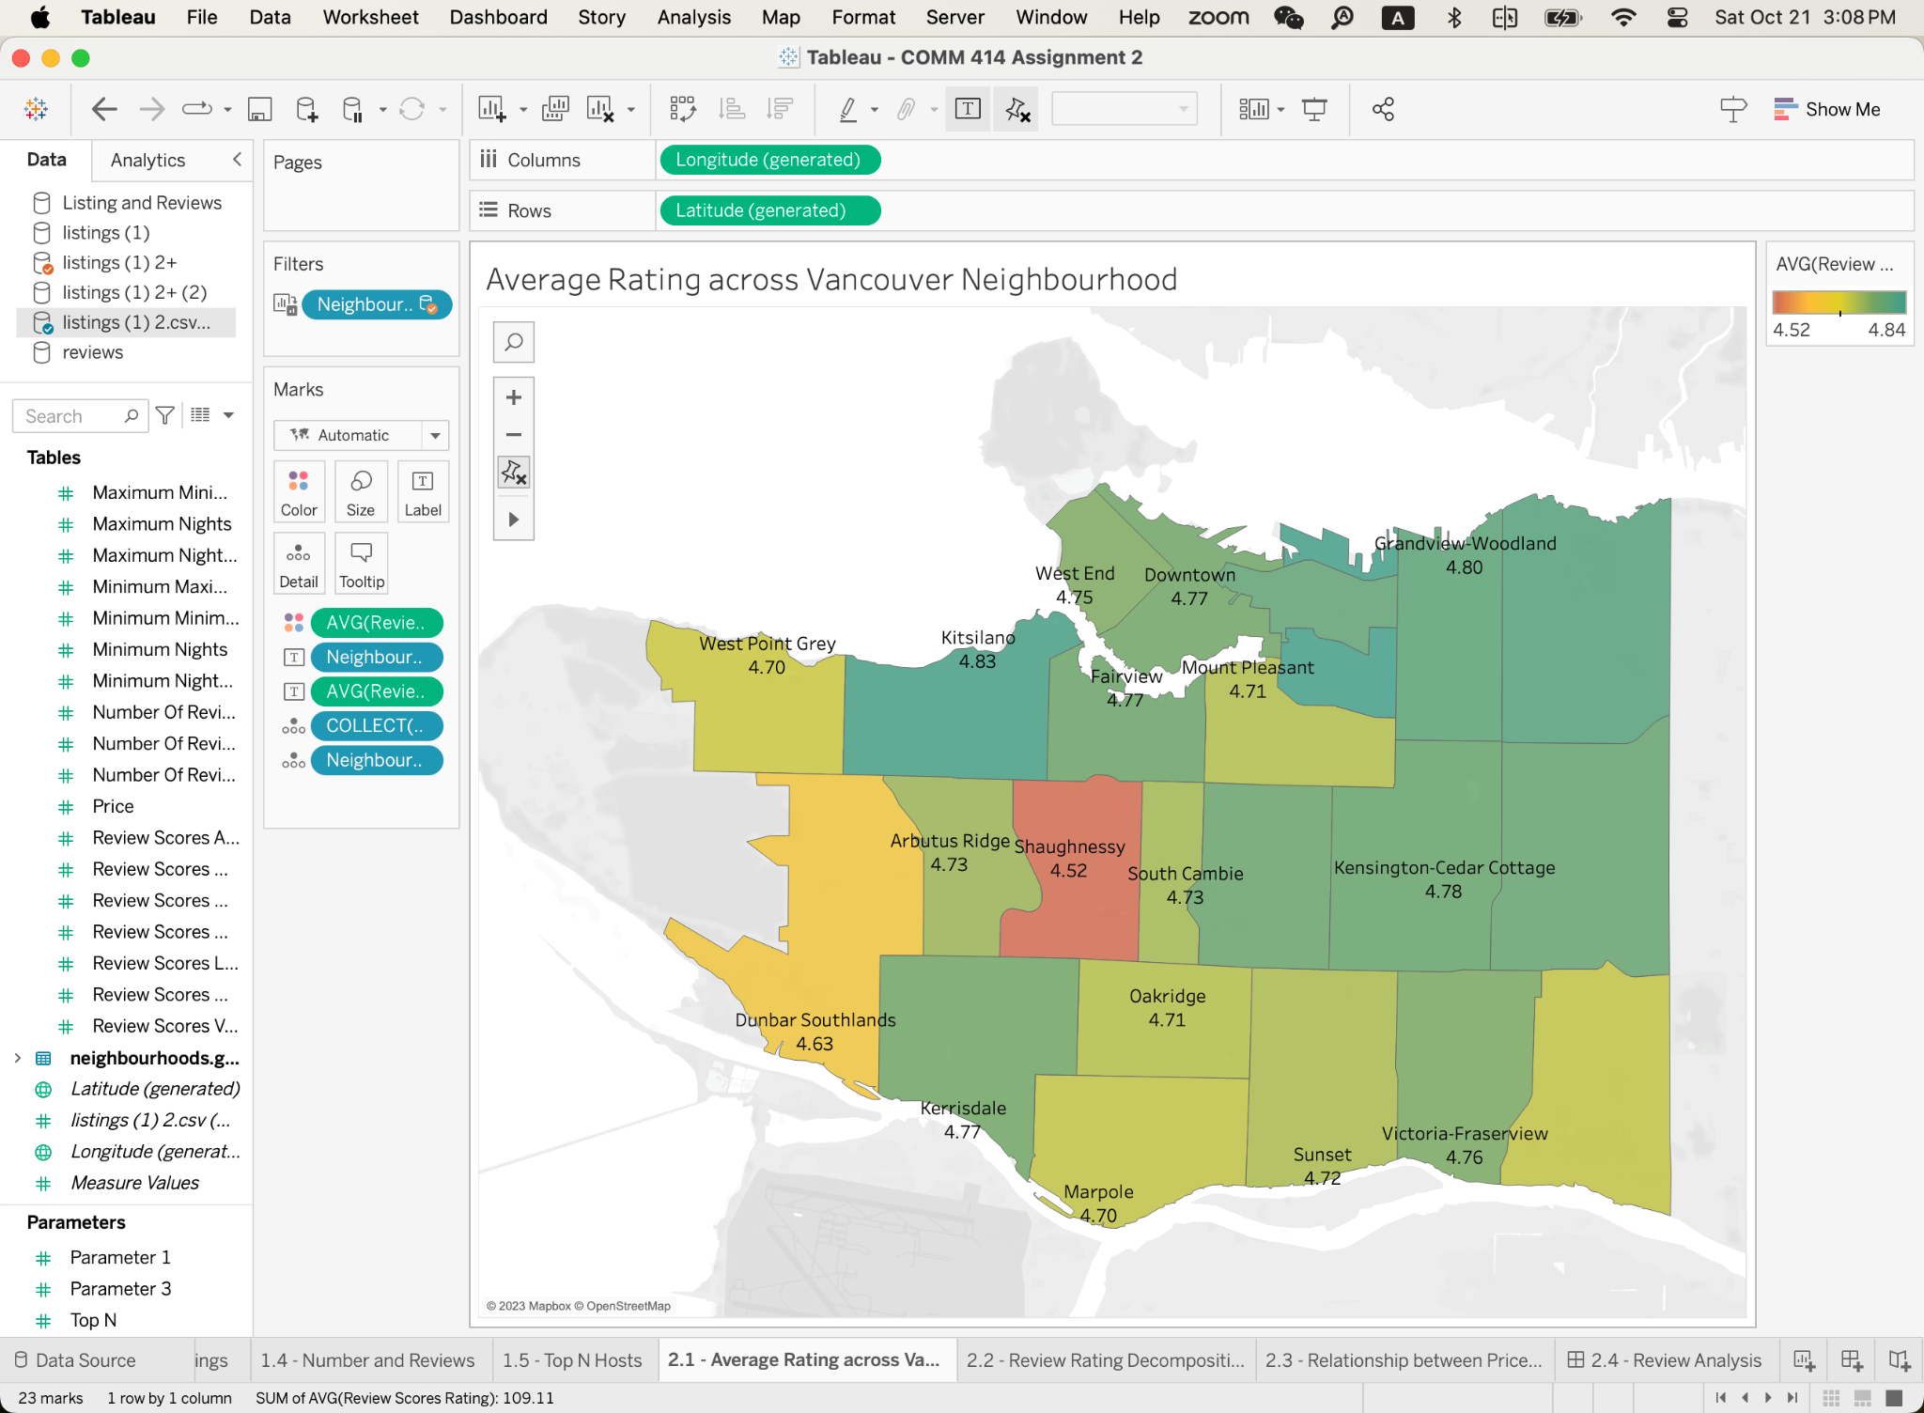

***2.2 Review Rating Decomposition***

To gain a comprehensive understanding of the Review Score Ratings, we have broken down the scores into the individual metrics used for the calculation: **(1) Review Score Location, (2) Review (3) Score Check-in, (4) Review Score Cleanliness, and (5) Review Score Communication.**

For this visualization, we employed a stacked bar chart to display the cumulative average review ratings from the four metrics, distinguishing each with unique colours. Considering that the majority of the ratings falls between 4 and 5, a simple summation of the average values would not be effective in highlighting their differences. Therefore, we chose to standardize the review scores before aggregating them, and rank the neighbourhood sum of standardized score in descending order.

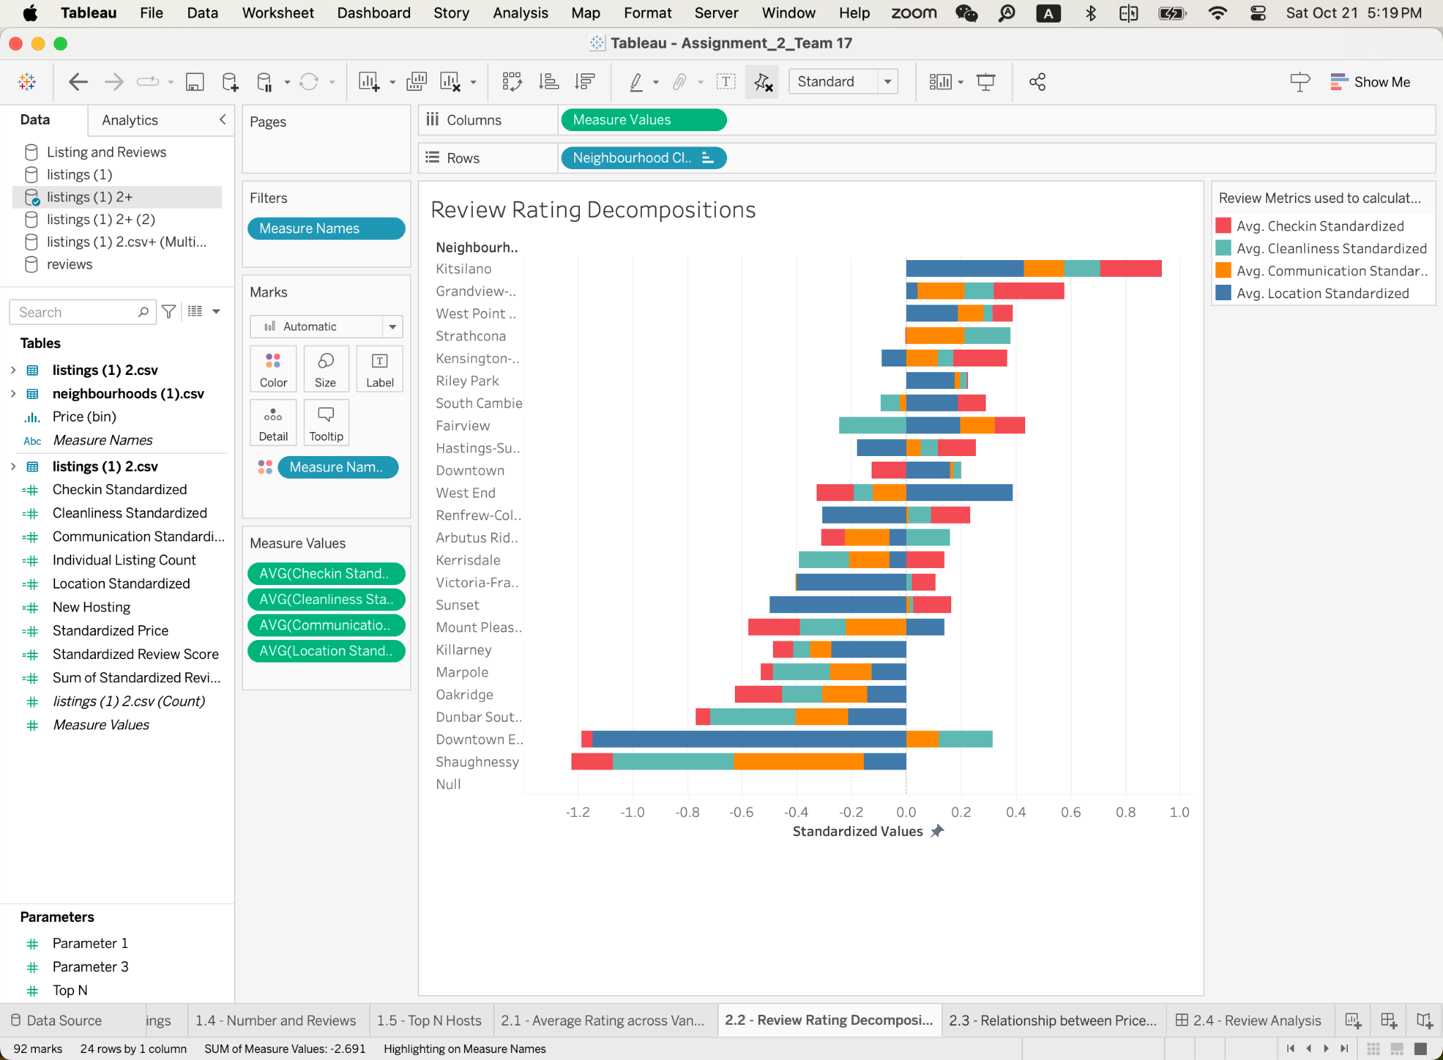

The results we obtained in this visualization is consistent with the previous visualization (Average Rating Across Vancouver Neighbourhoods), where Kitsilano has the highest total score (standardized) and Shaughnessy has the lowest. Another interesting observation is that the Downtown Eastside neighbourhood has the lowest Location score, which isn’t surprising given the high crime rates in the area.

***2.3 Relationship between Price and Review Categories (Standardized)***

To further explore the possibility that a higher score could translate to increased earnings for hosts, we plotted the relationship between the standardized score and price (with price serving as a proxy for profit). This was visualized using a scatter plot, accompanied by a linear trend line. Intuitively, a steeper slope suggests a greater financial reward for each unit increase in the standardized review score. Additionally, we incorporated a neighbourhood filter, enabling users to view statistics specific to individual neighbourhoods. By examining these scatterplots, hosts can gain insights into which areas of improvement might offer the most significant marginal benefits, depending on the neighbourhood in which they operate in.

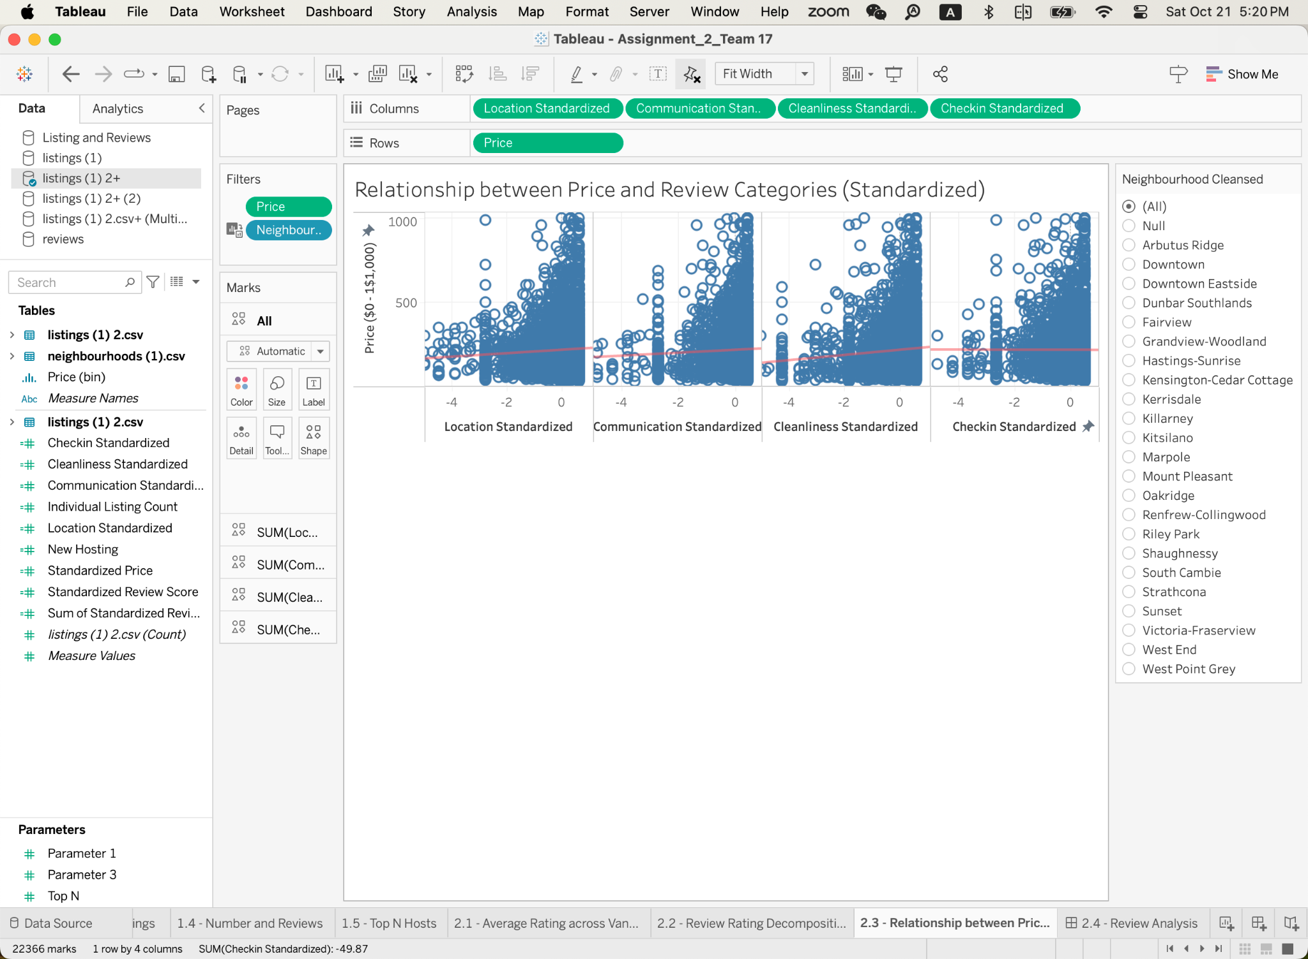

Overall, Cleanliness emerges as the most influential factor impacting price, with the steepest slope of 15.3315. This is followed by Location at 10.2429 and Communications at 8.69675. Interestingly, Check-in has a slightly negative slope of -0.222342. Although these figures establish a linear relationship statistically, their significance will require further analysis. It's worth noting that the values differ substantially across neighbourhoods, and users should interpret these statistics within their specific neighbourhood context in mind. In addition, in Question I) 3), we discovered that almost all prices falls below $1000 in Vancouver. To evaluate the relationship in a more generalized perspective and to eliminate the impact of outliers and missing data such as skewed results or assumption violations, we restricted our dependent variable to prices within the range of $0 to $1,000.

***2.4 Analysis of Review by Neighbourhood (The Dashboard)***

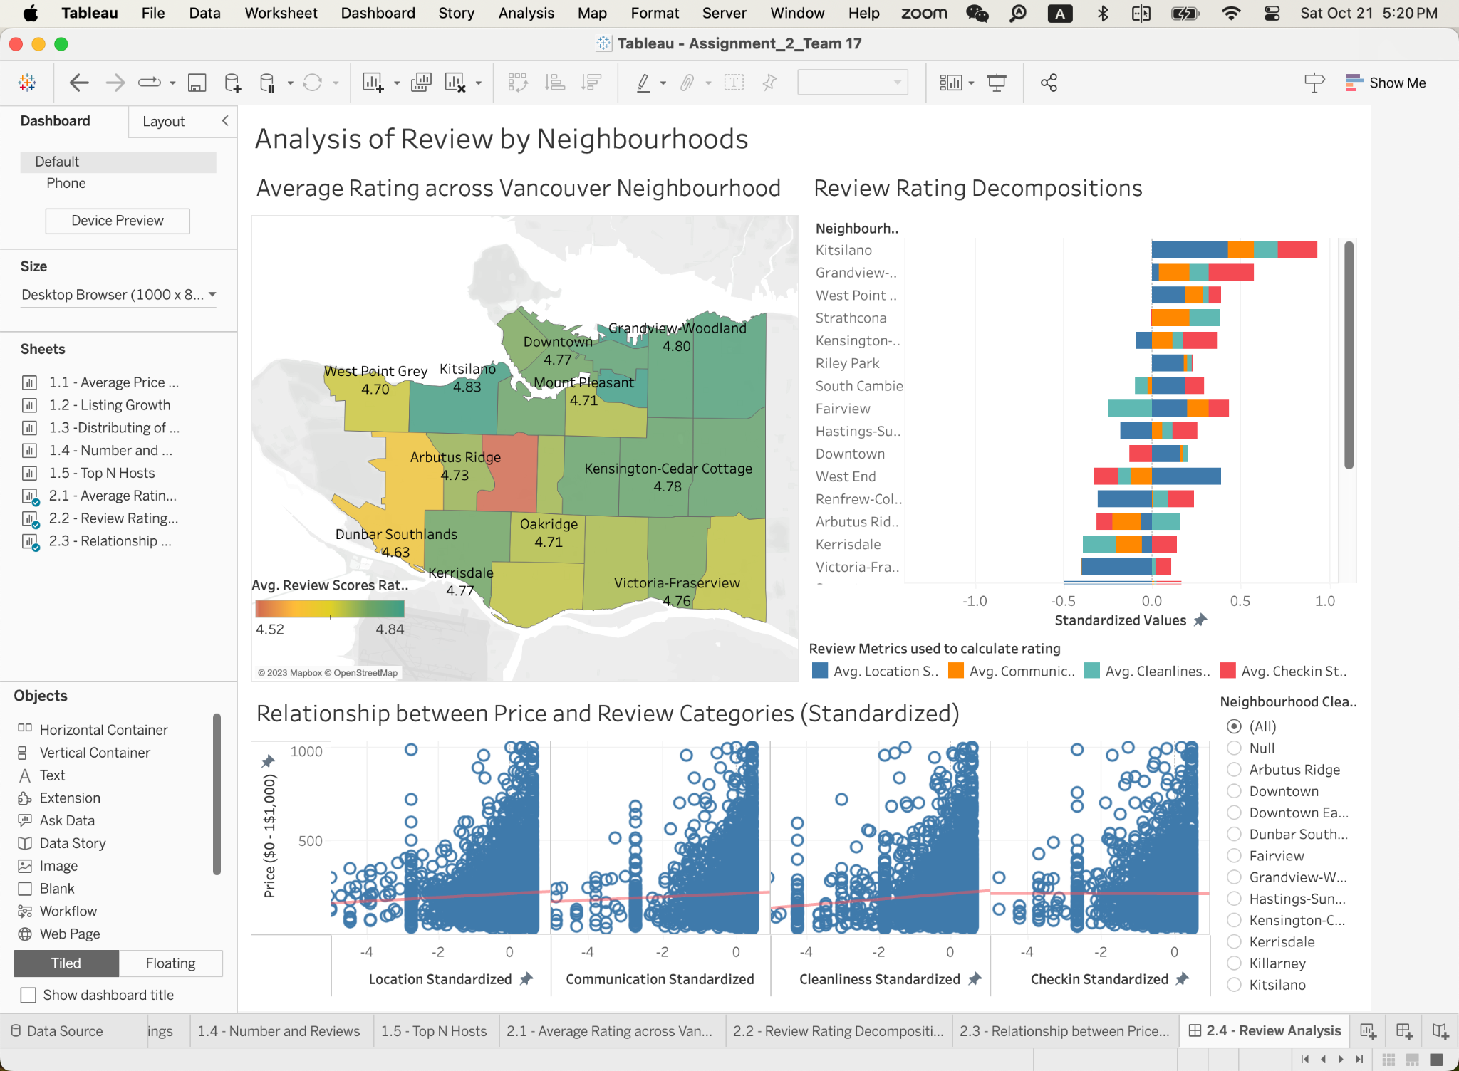

The final product is the **“Analysis of Reviews by Neighbourhoods” Dashboard,** created using the three individual worksheets outlined above. This interactive tool enables hosts to select and compare different neighborhoods using the "Neighborhood" selection pane, providing a comprehensive understanding of their position in the context of accommodation quality and prices charged, evaluated against other listings.